**OMNI POLL – A SYSTEM FOR THE NEW DEMOCRACY**

**1. INTRODUCTION**

Omni Poll is an online voting technique. In this system people who have citizenship of India and whose age is above 18years and any sex can give their vote online without going to any physical polling station. There is a database which is maintained n which all the names of voters with complete information is stored.

In Omni Poll, a voter can use his/her voting right online without any difficulty. He/she has to be registered first for him/her to vote. Registration is mainly done by the System Administrator due to security constraints. The System Administrator registers the voters on a special site of the system visited by him only by simply filling a registration form to register voter. Citizens seeking registration are expected to contact the System Administrator to submit their details. After the validation of them being the citizens of India has been confirmed by the System Administrator by comparing their details submitted with those in existing databases such as those as the Registrar of persons, the citizen is then registered as a voter.

After registration, the voter is assigned a secret voter ID with which he/she can use to login into the system and cast their vote. If invalid details are submitted, then the citizen is not registered to vote.

* 1. **Background**

The Omni Poll also known as e-voting is a term encompassing several different types of voting embracing both electronic means of counting votes. Electronic voting technology can include punched cards, optical scan voting systems and specialized voting kiosks. It can also involve transmission of ballots ad votes via telephones, private computer networks, or the internet.

Omni Poll is an electronic way of choosing leaders via a web driven application. The advantage of Omni Poll over the common “Queue method” is that the voters have the choice of voting at their own free time and there is reduced congestion. It also minimizes on errors of vote counting. The individual votes are submitted in a database which can be queried to find out who of the aspirants for a given post has the highest number of votes.

This system is generated towards increasing the voting percentage in India since it has been noted that the old voting method, the voter turnout has been a wanting case. With system in place also, if high security is applied, cases of false votes shall be reduced.

With the “Omni Poll”, a voter can use his/her voting right online without any difficulty. He/she has to register as a voter first before being authorized to vote. The registration should be done prior to the voting date to enable data update in the database.

However, not just anybody can vote. For one participate in the elections, he/she must have to meet certain requirements. For instance, he/she must be a registered citizen i.e. must be 18 and above years old. As already stated, the project ‘Omni Poll’ provides means for fast and convenient voting and access to this system is limited only to the registered voters.

Internet voting systems are appealing for several reasons which include people are getting more used to work with computers to do all sorts of things such as shopping, internet banking and they allow people vote far from where they usually live, helping to reduce absenteeism rate.

* 1. **Objective:**

The specific objectives of this project include

* Reviewing the existing/current voting process or approach in India
* Coming up with an automated voting system in India
* Implementing an automated Omni Polling system
* Validating the system to ensure that only legible voters are allowed to cast their vote
  1. **Project Justification:**

The Omni Poll – A system for the new Democracy, shall reduce the time spend making long queues at the polling stations during voting. It shall also enable the voters to vote from any part of the globe as explained since this is an Online application available on the Internet. Cases of vote miscounts shall also be solved since at the backend of this system resides a well deployed database using MYSQL that can provide the correct data once it is correctly queried. Since the voting process shall be open as early as possible, the voters shall have ample time to decide when and whom to vote for.

**2. SURVEY OF TECHNOLOGIES**

* 1. **Software requirements:**

**MYSQL DBMS**

MYSQL, the most popular Open Source SQL database management system, is developed. Distributed and supported by Oracle Corporation.

A database is a structured collection of data. It may be anything from a simple shopping list to picture gallery or the vast amounts of information in a corporate network. To add, access, and process data stored in a computer database, you need a database management such as MYSQL Server. Since computers are very good at handling large amounts of data, database management systems play a central role in computing, as standalone utilities, or as parts of other applications.

A relational database stores data in separate tables rather than putting all the data in one big storeroom. The database structures are organized into physical files optimized for speed. The logical model, with objects such as databases, tables, views, rows, and columns, offers a flexible programming environment. You set up rules governing the relationships between different data fields, such as one-to-one, one-to-many, unique, required or optional, and “pointers” between different tables.

The SQL part of “MySQL” stands for “Structured Query Language”. SQL is the most common standardized language used to access databases. Depending on your programming environment, you might enter SQL directly (for example, to generate reports), embed SQL statements into code written in another language, or use a language-specific API that hides the SQL syntax.

**NetBeans IDE 7.1.2**

The NetBeans IDE is an award-winning integrated development environment available for Windows, Mac, Linux and Solaris. The NetBeans project consists of an open-source IDE and an application platform that enable developers to rapidly create web, enterprise, desktop and mobile applications using Java platform, as well as PHP, JavaScript and Ajax, Groovy and Grails and C/C++.

The NetBeans project is supported by a vibrant developer community and offers extensive documentation and training resources as well as diverse selection of third-party plugins.

**JAVA coding**

This is for advanced user who find PHP codes easy to work with.

**Testing** – is done via WAMPSERVER

**Web browsers:** Mozilla Firefox, Google Chrome, Opera and Internet Explorer.

**Reporting Tool** i.e. through Data Report

* 1. **Hardware Requirements**

**Microsoft Windows XP Professional SP3/Vista SP1/Windows 7/Windows 10 Professional:**

**Processor:** 800MHz Intel Pentium III or equivalent

**Memory:** 512 MB

**Disk Space:** 750 MB of free disk space

**3 PLANNING AND SCHEDULING**

The project is planned to complete in three months’ timeline, covering all the stages in the chosen conventional model. In our case, we have chosen the Waterfall model. We have estimated two weeks’ time for identifying the requirement and analysis for Omni Poll – A system for the new Democracy. The design of the project and identifying the entity and their relations will be done in next two weeks. Fully implementation of the project and coding will need a month. Testing for the project will require two weeks and fixing the issues found / maintenance will be done in the last two weeks.

**Schedule:**

|  |  |
| --- | --- |
| **Task** | **No of Days / Weeks** |
| Requirement Analysis | 2 weeks |
| Designing | 2 weeks |
| Coding | 4 weeks |
| Testing | 2 weeks |
| Maintenance | 2 weeks |
| Documentation | 3 days |

**Implementation:**

|  |  |  |  |  |  |  |
| --- | --- | --- | --- | --- | --- | --- |
| **TASK** | **Week 1-2** | **Week 3-4** | **Week 5-6** | **Week 7-8** | **Week 9-10** | **Week 11-12** |
| **Requirement Gathering** |  |  |  |  |  |  |
| **Designing** |  |  |  |  |  |  |
| **Coding** |  |  |  |  |  |  |
| **Testing** |  |  |  |  |  |  |
| **Maintenance** |  |  |  |  |  |  |

* 1. **Scope of Solution**

It is focused on studying the existing system of voting in Kenya and to make sure that the peoples vote is counts, for fairness in the elective positions. This is also will produce:

* Less effort and less labor intensive, as the primary cost and focus primary on creating, managing, and running a secure web voting portal.
* Increasing number of voters as individuals will find it easier and more convenient to vote, especially those abroad.

**4. CONCEPTUAL MODEL**

We are approaching Waterfall model to implement Omni Poll.

**Waterfall** **Model:**

It is the simplest, oldest and most widely used process model. In this model, each phase of the life cycle is completed before the start of a new phase. It is actually the first engineering approach of software development. Below figure depicts the Waterfall Model.

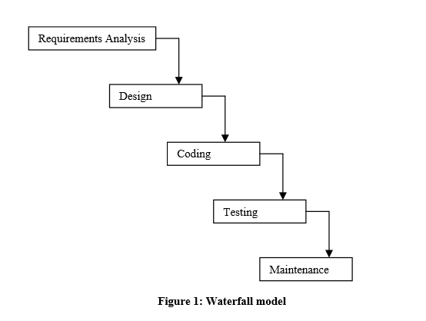

The function of various phases is discussed in software process technology. The waterfall model provides a systematic and sequential approach to software development and is better than the build and fix approach. But, in this model, complete requirement should be available at the time of commencement of the project, but in actual practice, the requirements keep originating during different phases. The waterfall model can accommodate new requirements only in maintenance phase. Moreover, it does not incorporate any kind of risk assessment. In the waterfall model, a working model of software is not available. Thus, there is no way of judging the problems between different phases. A slight modification of the waterfall model is a model with feedback. Once software is developed and is operational, then the feedback to various phases may be provided.

**5. DATA FLOW DIAGRAMS**

Data flow diagram is the starting point of the design phase that functionally decomposes the requirements specification. A DFD consists of a series of bubbles joined by lines. The bubbles represent data transformation and the lines represent data flows in the system. A DFD describes what data flow rather than how they are processed, so it does not hardware, software and data structure.

A data flow diagram (DFD) is a graphical representation of the flow of data through an information system. DFDs can also be used for the visualization of data processing. A data flow diagram is a significant modeling technique for analyzing and constructing information processes. DFD literally means an illustration that explains the course or movement of information in a process. DFD illustrates this flow of information in a process based on the inputs and outputs. A DFD can be referred to as a process model.

**Level 0**

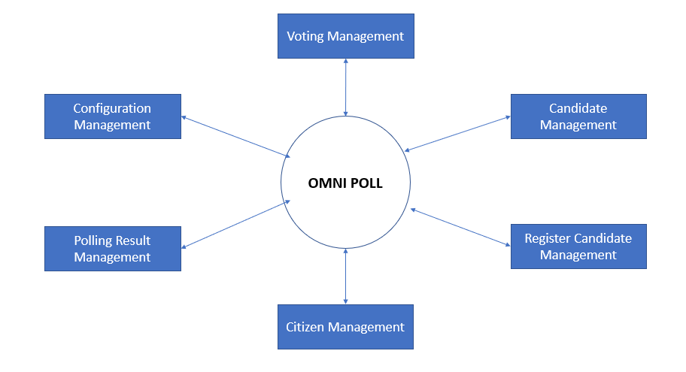

**Level 1**

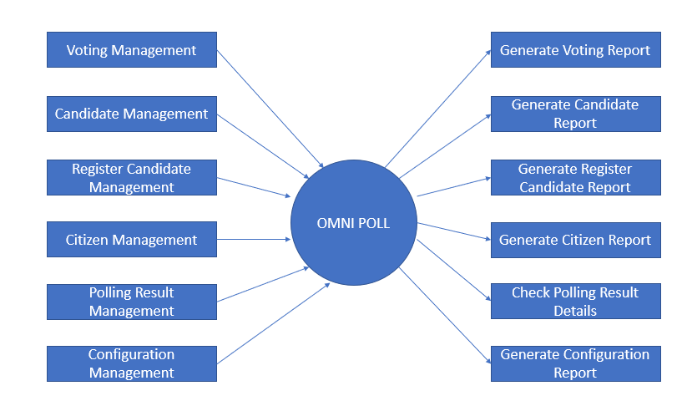

**Level 2**

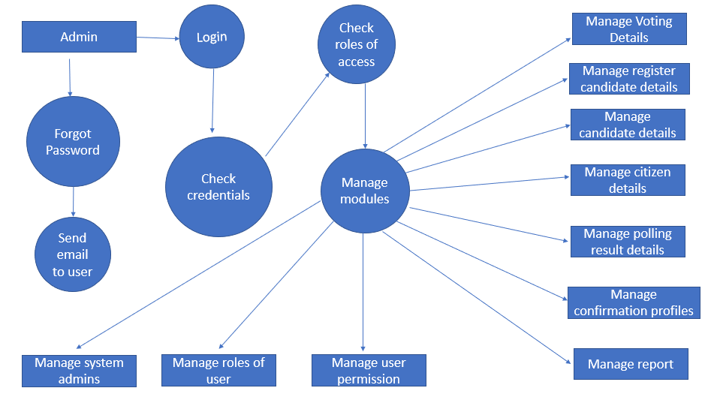

**6. E-R DIAGRAM**

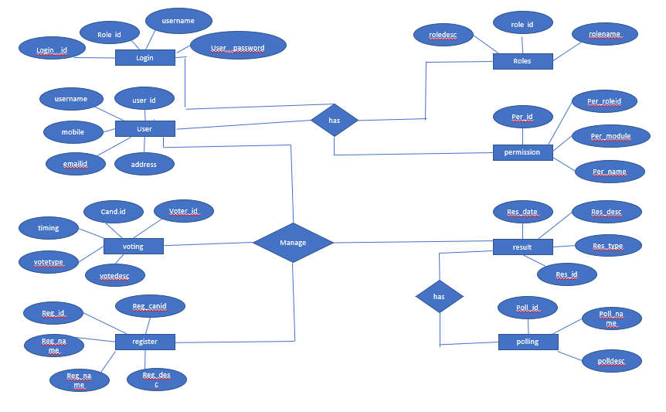

**7. ACTIVITY DIAGRAM**

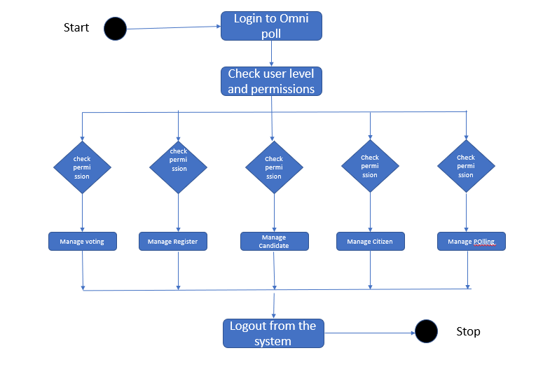

**8. DATABASE TABLES**

This project uses below tables

1. Admin
2. Voter
3. Candidate

**Admin table:**

|  |  |  |
| --- | --- | --- |
| **Field Name** | **Data Type** | **Description** |
| Username | Varchar | Login ID for Admin (Primary key) |
| Password | Varchar | Password for login |

**Voter table:**

|  |  |  |
| --- | --- | --- |
| **Field Name** | **Data Type** | **Description** |
| VoterID | Integer | Login ID for voter (Primary key) |
| Name | Varchar | Name of voter |
| Sex | Varchar | Sex of voter |
| Age | Integer | Age of voter |
| City | Varchar | City of voter |
| Security | Varchar | Security question |
| Status | Boolean | Status of voter (he/she can vote or not) |

**Candidate table:**

|  |  |  |
| --- | --- | --- |
| **Field Name** | **Data Type** | **Description** |
| Symbol | Varchar | Party symbol (Primary key) |
| Name | Varchar | Name of candidate |
| Sex | Varchar | Sex of candidate |
| Age | Integer | Age of candidate |
| City | Varchar | City of candidate |
| Count | Integer | Count of no of votes |

**9. MODULES OF THE PROJECT**

**9.1 About page:**

This page allows the guest users and legitimate users to read about the platform. So it contains information regarding our aims, objectives, goals and our missions.

**9.2 Categories page:**

This page allows the users to view the lists of voting categories available for voting, inside which lies the lists of all the contenders for each category.

**9.3** **Login page:**

The login page in the face of entry to the secure environment where users can have access to the coting interface. It contains two options, the username textbox and password textbox then one login button.

**9.4 Sign up page:**

The sign-up page is composed of a number of web controls and validation controls, which are used to take values from the user in preparation for allowing access to the platform. It has textboxes like Name, Email, Password, Address and Submit button.

**9.5 Admin page:**

This page consists of a username textbox and a password textbox. Admin has the access to verify the citizens’ data, validation and to add the details about contenders and publishing the final result.

**9.6 Voter page:**

This page contains details about citizens like name, age, sex, voter ID etc.

**9.7 Polling page:**

This page contains fields like the candidate for whom a voter wishes to cast their vote and the symbol of it.

**10. SECURITY ISSUES OF OMNI POLLING**

Foreign experience revealed that they are often confronted by security issues while the Omni Polling system is running. The origin of the security issues was due to not only outsider (such as voters and attackers) but also insider (such as system developers and administrators), even just because the inheritance of some objects in the source code are unsuitable. These errors caused the voting system to crash.

The proposed solutions were correspondingly outlined to hold back these attacks. For example, to avoid hacker making incursion into the voting system via network, we can design our system to transmit data without network. Another example is o limit voter to input particular data, so that we can prevent the command injection from running.

**11. FUTURE SCOPE**

The future of this project lies in the hands of users. Although we also have a part to play. This is through enhancing the features of this system by introducing concepts and functionalities which are trending with other systems. However, maintenance is the most important thing that determines the future scope any software. By constant maintenance, debugging and providing security checks we hope the system should be able to survive those future challenges. One most important thing is that, if this project is able to be adopted by the Government and Private Sectors for election purpose, then it is going to be a remarkable achievement for the entire system and the team. This is why we hope to reintroduce the idea using **Omni Poll – A system for the new Democracy** through campaign and promos to enlighten the general public on the importance of digitalizing elections and all forms of voting for the betterment of the people, security and fairness.

**12. BIBLIOGRAPHY AND REFERENCES**

**Books:**

1. Head First PHP & MySQL – by Lynn Beighley & Michael Morrison
2. Code complete: A practical handbook of programming and software construction
3. Software Engineering by Rajib Mall

**References:**

[www.udemy.com](http://www.udemy.com)

<https://wn.m.wikibooks.org>